1-File Transfer Protocol (FTP)
# Source: AI Source: Provided by: [Data Path: Persons Table -> ID Column: 1, Name_En Column: Motasem Essam] -> From: [ChatGPT] on [1/18/2026]
File Transfer Protocol (FTP) is a standard network protocol used to transfer files between a client and a server over a computer network, such as the Internet.

Key Features of FTP:
# Source: AI Source: Provided by: [Data Path: Persons Table -> ID Column: 1, Name_En Column: Motasem Essam] -> From: [ChatGPT] on [1/18/2026]
- Two-way transfer: Upload files from client to server or download from server to client.
- Operates on TCP/IP and typically uses:
  - Port 21 for commands/control
  - Port 20 for data transfer (in active mode)
- Requires authentication (username/password), but can also allow anonymous access.
- Supports directory navigation, file renaming, deletion, and permission changes.

Modes of Operation:
# Source: AI Source: Provided by: [Data Path: Persons Table -> ID Column: 1, Name_En Column: Motasem Essam] -> From: [ChatGPT] on [1/18/2026]
- Active Mode: The server initiates the data connection.
- Passive Mode: The client initiates both control and data connections (better for firewalls).

Security Considerations:
# Source: AI Source: Provided by: [Data Path: Persons Table -> ID Column: 1, Name_En Column: Motasem Essam] -> From: [ChatGPT] on [1/18/2026]
- Standard FTP is not secure — it sends data, including passwords, in plain text.
- Secure alternatives:
  - FTPS (FTP Secure): Adds SSL/TLS encryption.
  - SFTP (SSH File Transfer Protocol): Uses SSH to securely transfer files (not the same protocol as FTP).

🧰 Common SFTP Clients
# Source: AI Source: Provided by: [Data Path: Persons Table -> ID Column: 1, Name_En Column: Motasem Essam] -> From: [ChatGPT] on [1/18/2026]
- FileZilla
- WinSCP
- Cyberduck
- Command line (sftp command)

Common Use Cases:
# Source: AI Source: Provided by: [Data Path: Persons Table -> ID Column: 1, Name_En Column: Motasem Essam] -> From: [ChatGPT] on [1/18/2026]
- Website file management (e.g., uploading HTML files to a server).
- Transferring large files between systems.
- Remote backups and file sharing.

visual explaining how FTP works?
# Source: AI Source: Provided by: [Data Path: Persons Table -> ID Column: 1, Name_En Column: Motasem Essam] -> From: [ChatGPT] on [1/18/2026]
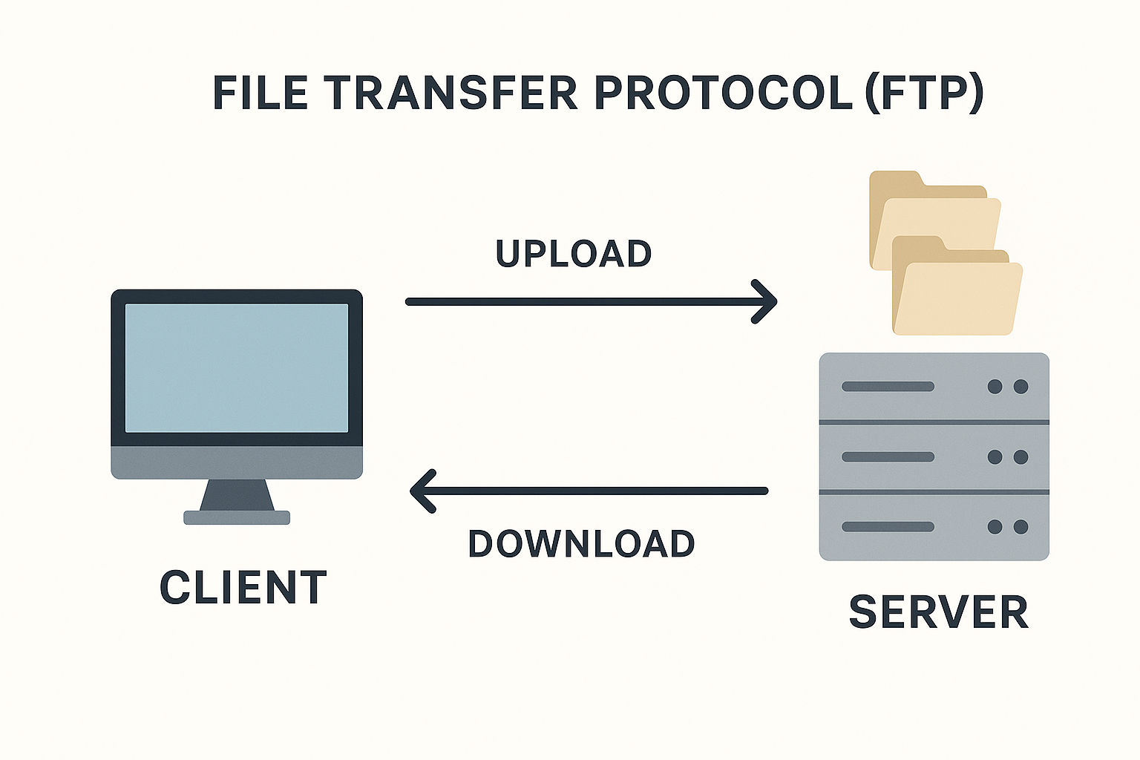

2-FTPS
# Source: AI Source: Provided by: [Data Path: Persons Table -> ID Column: 1, Name_En Column: Motasem Essam] -> From: [ChatGPT] on [1/18/2026]
FTPS (File Transfer Protocol Secure) is a secure version of FTP (File Transfer Protocol) that uses SSL/TLS encryption to protect data during transfer.

🔐 What FTPS Does
# Source: AI Source: Provided by: [Data Path: Persons Table -> ID Column: 1, Name_En Column: Motasem Essam] -> From: [ChatGPT] on [1/18/2026]
FTPS allows users to upload, download, and manage files on a remote server securely — just like FTP, but with encryption.

🔹 Key Features of FTPS
# Source: AI Source: Provided by: [Data Path: Persons Table -> ID Column: 1, Name_En Column: Motasem Essam] -> From: [ChatGPT] on [1/18/2026]

Feature | Description
🔒 Encryption | Uses SSL/TLS to encrypt data (same tech used in HTTPS)
✅ Authentication | Supports usernames/passwords, and also digital certificates
📡 Ports | Uses port 21 for commands, and random ports for data (passive mode)
🧱 Firewall-Friendly? | Less so than SFTP (more complex with multiple ports)

🔄 How FTPS Works (Simplified)
# Source: AI Source: Provided by: [Data Path: Persons Table -> ID Column: 1, Name_En Column: Motasem Essam] -> From: [ChatGPT] on [1/18/2026]
- You connect to the server using an FTPS-compatible client (e.g., FileZilla).
- The server and client perform a TLS handshake to establish a secure connection.
- You log in (credentials are encrypted).
- You can now upload/download files securely.

🔀 FTPS vs FTP vs SFTP
# Source: AI Source: Provided by: [Data Path: Persons Table -> ID Column: 1, Name_En Column: Motasem Essam] -> From: [ChatGPT] on [1/18/2026]

Feature | FTP | FTPS | SFTP (different protocol)
Security | ❌ No encryption | ✅ SSL/TLS encryption | ✅ SSH encryption
Port | 21 | 21 + random data ports | 22 (single port)
Protocol Type | TCP | TCP | SSH (not FTP-based)
Compatibility | Widely supported | Supported by FTP clients | Requires SSH-based software

✅ When to Use FTPS
# Source: AI Source: Provided by: [Data Path: Persons Table -> ID Column: 1, Name_En Column: Motasem Essam] -> From: [ChatGPT] on [1/18/2026]

- You need secure file transfer in an environment already using FTP
- You need to comply with data protection regulations (e.g., HIPAA, PCI-DSS)
- Your partners require SSL/TLS-based authentication

3-SFTP
# Source: AI Source: Provided by: [Data Path: Persons Table -> ID Column: 1, Name_En Column: Motasem Essam] -> From: [ChatGPT] on [1/18/2026]
SFTP (SSH File Transfer Protocol) is a secure file transfer protocol that operates over SSH (Secure Shell). It allows you to safely upload, download, and manage files on a remote server.
🔐 Unlike FTP or FTPS, SFTP is not related to FTP — it's built on SSH, not TCP/FTP.

🔹 Key Features of SFTP
# Source: AI Source: Provided by: [Data Path: Persons Table -> ID Column: 1, Name_En Column: Motasem Essam] -> From: [ChatGPT] on [1/18/2026]

Feature | Description
🔒 Security | Encrypts both commands and data using SSH
🌐 Port | Uses port 22 (same as SSH) — easier for firewalls
🧰 Functions | File upload/download, directory management, permissions
🧑‍💻 Authentication | Uses SSH keys or username/password

🔄 How SFTP Works
# Source: AI Source: Provided by: [Data Path: Persons Table -> ID Column: 1, Name_En Column: Motasem Essam] -> From: [ChatGPT] on [1/18/2026]
- You connect to a remote server via SSH (Secure Shell)
- SFTP runs over this encrypted SSH session
- You can now transfer and manage files securely

🔀 SFTP vs FTP vs FTPS
# Source: AI Source: Provided by: [Data Path: Persons Table -> ID Column: 1, Name_En Column: Motasem Essam] -> From: [ChatGPT] on [1/18/2026]

Feature | FTP | FTPS | SFTP
Encryption | ❌ None | ✅ SSL/TLS | ✅ SSH
Port | 21 + random | 21 + random | ✅ 22 (single port)
Protocol Base | FTP | FTP + SSL/TLS | ✅ SSH-based (not FTP)
Firewall Friendly | ❌ Not very | ❌ Complex | ✅ Yes (single port)
Authentication | Username/password | Username/password, certs | ✅ Username/password or SSH key

✅ Why Use SFTP?
# Source: AI Source: Provided by: [Data Path: Persons Table -> ID Column: 1, Name_En Column: Motasem Essam] -> From: [ChatGPT] on [1/18/2026]
- Security-first environments (e.g., hospitals, finance, government)
- You already use SSH for server access
- Need for firewall-friendly secure file transfer (single port)
- You want both data encryption and integrity

